Document No.: INTEGRATION_TEST_01_001

Device Integration Test Procedure
Part 01

12 October 2016



Revision 0.4

Lincoln Laboratory
Massachusetts Institute of Technology
Lexington, Massachusetts

Copyright (c) 2016 Massachusetts Institute of Technology
WARNING: Information subject to export control laws. This document contains information subject to International Traffic in Arms Regulations (ITAR) or Export Administration Regulations (EAR), which may not be exported, released, or disclosed to foreign nationals inside or outside the United States without first obtaining prior U. S. government approval.

Permission is hereby granted, free of charge, to any person obtaining a copy of this software and associated documentation files (the "Software"), to deal in the Software without restriction, including without limitation the rights to use, copy, modify, merge, publish, distribute, sublicense, and/or sell copies of the Software, and to permit persons to whom the Software is furnished to do so, subject to the following conditions:
THE SOFTWARE IS PROVIDED "AS IS", WITHOUT WARRANTY OF ANY KIND, EXPRESS OR IMPLIED, INCLUDING BUT NOT LIMITED TO THE WARRANTIES OF MERCHANTABILITY, FITNESS FOR A PARTICULAR PURPOSE AND NONINFRINGEMENT. IN NO EVENT SHALL THE AUTHORS OR COPYRIGHT HOLDERS BE LIABLE FOR ANY CLAIM, DAMAGES OR OTHER LIABILITY, WHETHER IN AN ACTION OF CONTRACT, TORT OR OTHERWISE, ARISING FROM, OUT OF OR IN CONNECTION WITH THE SOFTWARE OR THE USE OR OTHER DEALINGS IN THE SOFTWARE.

Revision History
DATE | VER | REVISIONS  BY | SHEETS AFFECTED | SUMMARY OF CHANGES
10/12/2016 | 0.1 | EGC | All | Initial draft
10/12/2016 | 0.2 | ROS | 6 | Added test execution detail
10/13/2016 | 0.3 | EGC | Front Page | Added legal disclaimer
10/14/2016 | 0.4 | EGC | 9 | Added Modbus reference

Approvals

Prepared by: _____________________________ DATE: _____________
Mr. Reynaldo Salcedo Group 73
Mr. Ed Corbett Group 73

Approved by: _____________________________ DATE: _____________
Mr. Erik Limpaecher
Assistant Group Leader
Group 73 Energy Systems

Table of Contents

Revision History ii
Approvals iii
1 Introduction 5
1.1 Reference Documents 5
1.2 Test Equipment 5
2 Description 5
2.1 Test Approach 6
2.2 Model Simulation Diagram 6
3 Part 01 Tests 6
3.1 Test Procedure 6
3.1.1 Abbreviations 6
3.1.2 Initial conditions 6
3.1.3 Procedure 7
3.1.4 Modbus Reference 9
3.2 Summary of Results 10
4 Final Signoff 10

List of Illustrations
Figure 1 – INTEGRATION_TEST_01.mdl 8

List of Tables
Table 1 - Required Test Equipment 5
Table 2 - Test Sequence 7
Table 3 - Modbus Reference 9

Introduction
This procedure is the first of two procedures that will be used to verify the ability of vendor microgrid controllers (MCG) to communicate with the MITLL real-time computer model and associated device controllers that will be the centerpiece of the FY17 Microgrid Controller Symposium. This procedure focusses on interfaces for the feeder protection device, the CHP plant (thermal controls and natural gas genset controller), software relays, and the simulated demand management system (DMS) interface. The emphasis is on demonstrating communications capability of the MCG over Modbus/TCP.

Reference Documents
The main reference document is 2016 HIL Microgrid Controller Packet v1.5.docx which is located on the public Github server at:

1. Link to 2016 HIL Microgrid Controller Packet v1.7.docx

Models used for Part 01 of the device integration testing (DIT) are available as a Simulink/SimPowerSystems/OPAL-RT model on the public Github server at the following locations:

1. Link to INTEGRATION_TEST_01.mdl
2. Link to CHP_Model_lib.mdl
3. Link to relay_modbus_lib.mdl
4. Link to Motor_InductionMachine_lib.mdl

Test Equipment
The test equipment shown in Table 1 will be provided by MITLL. Any additional test equipment that is required to demonstrate successful test execution will be the responsibility of the vendor.

1. HIL real-time model along with all initialization files and data files (e.g., load profiles)
2. HIL 3-rack equipment including keyboard and monitor
3. Woodward easYgen 3500 programming tool and computer with serial interface
4. SEL AcSELerator Quickset programming tool and laptop with Ethernet interface
5. Oscilloscope
Table 1 - Required Test Equipment

Description
As described above, the test will focus mainly on the MGC ability to support communications with the device controllers (Woodward and SEL) and the modelled Modbus devices (software relay and DMS).

Test Approach
The test approach will be to execute a pre-programmed sequence of operations which are listed in Section 3.1 below. Simple pass/fail criterion will be used to establish whether the MGC has met the required performance.

Model Simulation Diagram
Figure 1 shows the master block of the model that will be executed for the DIT.

Part 01 Tests
Date of test Start: _______________ Date of test End: ________________
Test Lead: _____________________ Time of Test ___________________

Test Procedure
The objective of this test (integration test 01) is to verify the proper microgrid controller communication and control of the following components:
- Natural Gas/CHP Plant
- Woodward Controller
- Hardware Relay SEL-751
- Software Generic Relay
- Dynamic Load
- Large Induction Motor
- Simulated DMS

Abbreviations
- MGC: Microgrid controller
- GCB: Generator circuit breaker (controller via Woodward)
- MID: Microgrid interconnection device

Initial conditions
- System is in steady state
- NG/CHP offline
- Induction motor offline
- Available loads are served by the utility-grid

Procedure

Test Sequence:
 | Pass(P) or Fail (F) | Initial
Grid-tied events
MGC: monitor system state to verify correct register-points are observed
DMS: turn on/off induction motor to observe MGC response
MGC: start genset with CHP disabled
MGC: parallel genset and pick-up available load
MGC: start CHP for electro-thermal co-optimization
MGC: vary CHP temperature set point
MGC: shed load under CB2
MGC: export power to the grid
MGC: reconnect CB2
Planned islanding – preparing for transition
DMS: send island request to MGC
MGC: perform load balancing for islanding
MGC: command islanding to MID relay (SEL751)
Islanded events
DMS: turn on/off induction motor to observe MGC response
MGC: shed load under CB2
Woodward/MGC: curtail generation
MGC: reconnect CB2
DMS: send reconnect permission to MGC
MGC: prepare to reconnect to the grid – active-vs-passive synchronism via Woodward?
MGC: command SEL751 to reclose MID
Grid-tied events
MGC: verify system operation
End of test sequence

Table 2 - Test Sequence
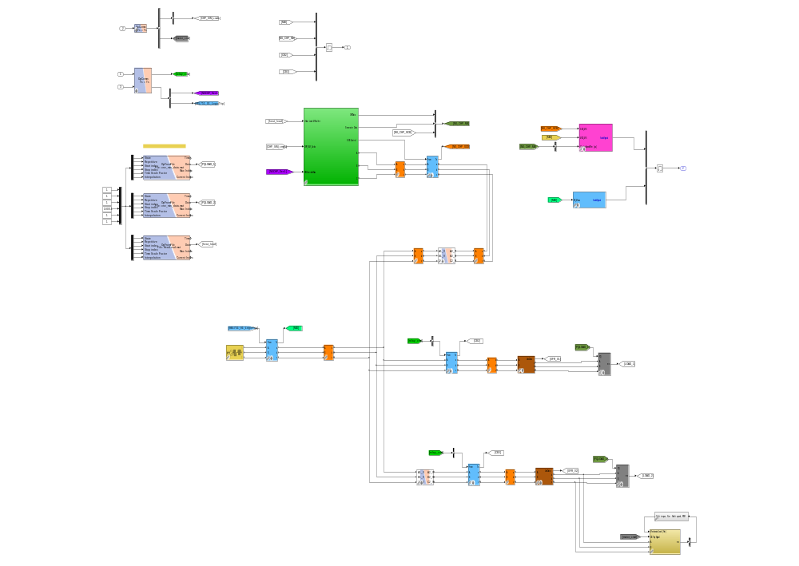
Figure 1 – INTEGRATION_TEST_01.mdl

Modbus Reference

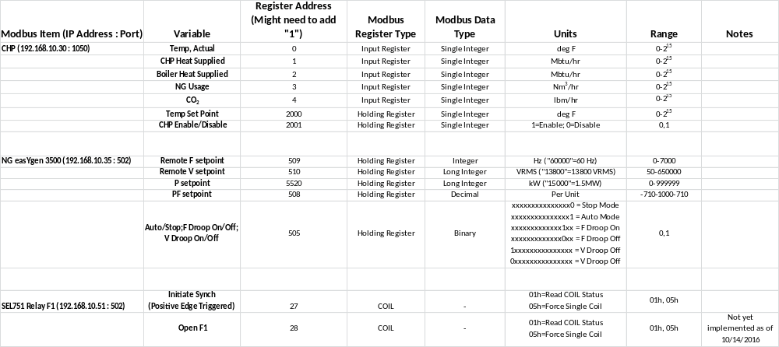

Table 3 - Modbus Reference

Summary of Results

Final Signoff

Approved by: _____________________________ Date: _____________
Mr. Reynaldo Salcedo Group 73
Mr. Ed Corbett Group 73

Approved by: _____________________________ Date: _____________
Mr. Erik Limpaecher
Assistant Group Leader
Group 73 Energy Systems

